Reviewe the Project and Clone the Repo ,
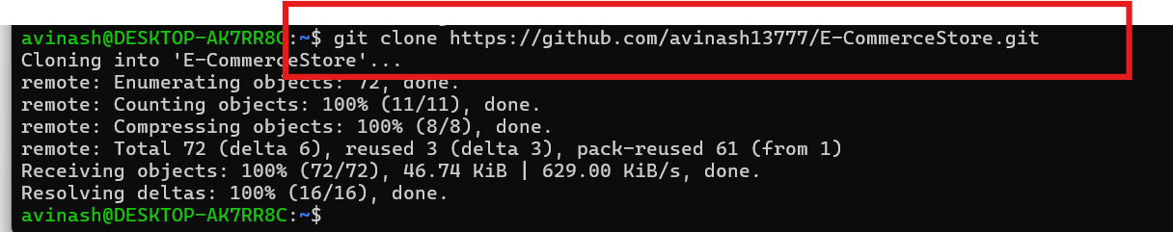
We need to creat the Docker file for the User -services ,
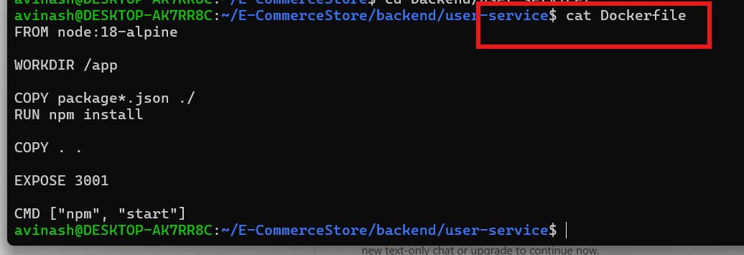
Nexr Production services
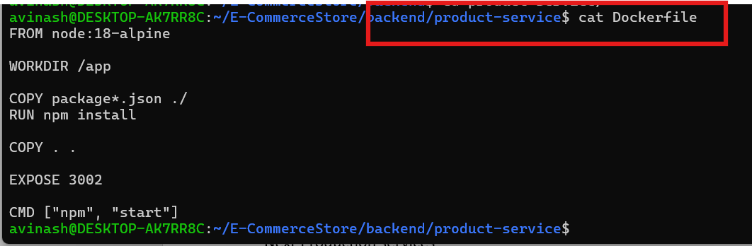
Created fro the cart docker file
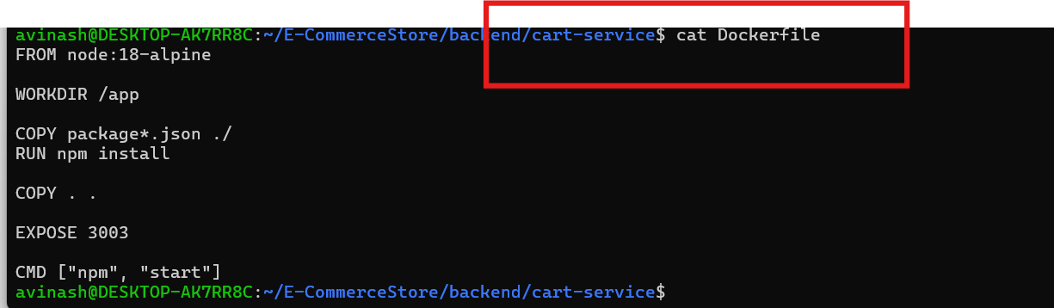Order services docker file
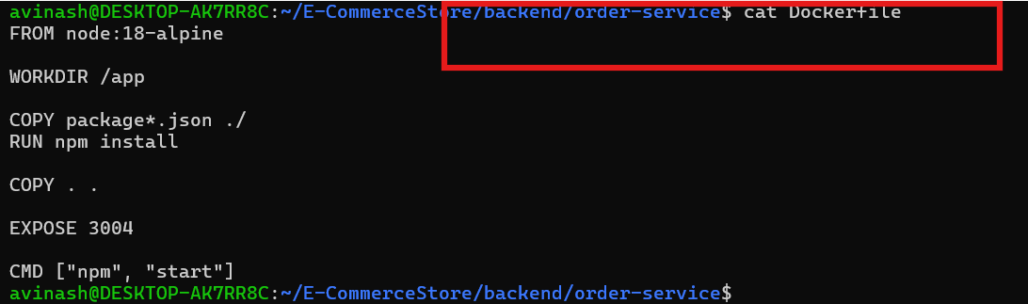
Created the Docker file for the Front end ,
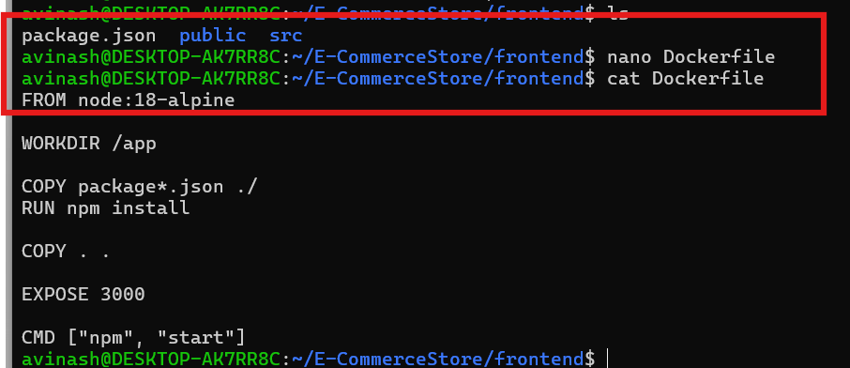

I can see all the docker file
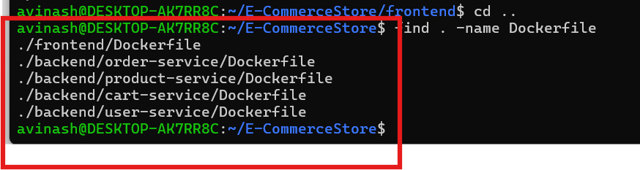
Starting the docker build for front end ,
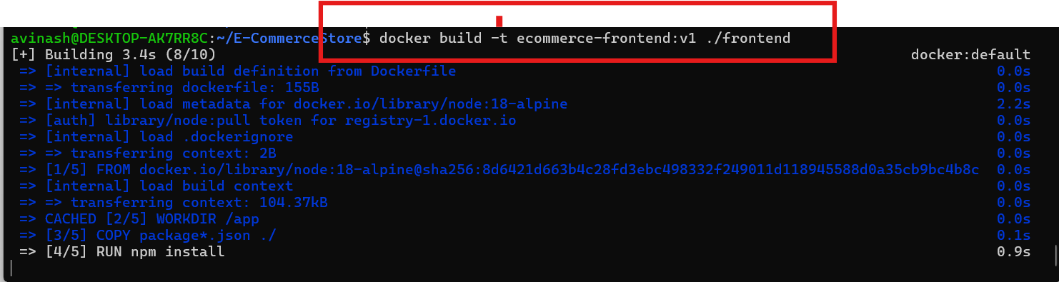
I can see the docker image
Same as I run the backedn user-services,
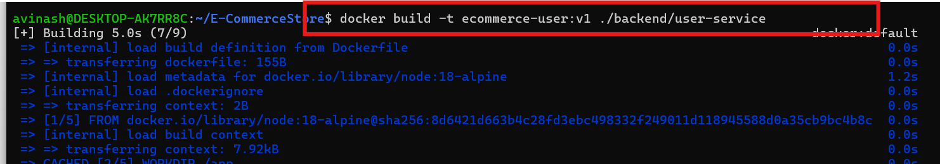
Same as I build the docker for the other services also
I have build the all the 5 docker images ,
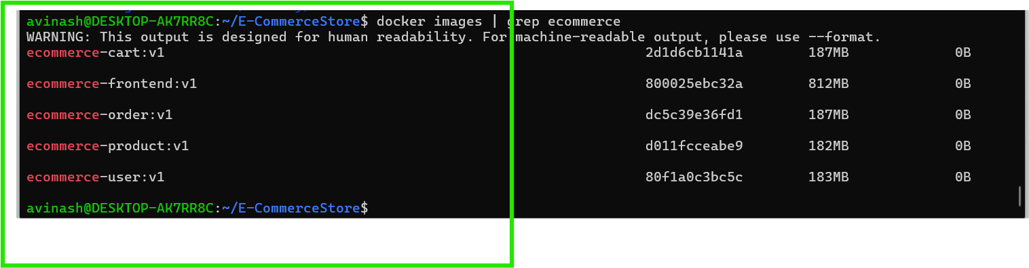
Now we need to run the all the services
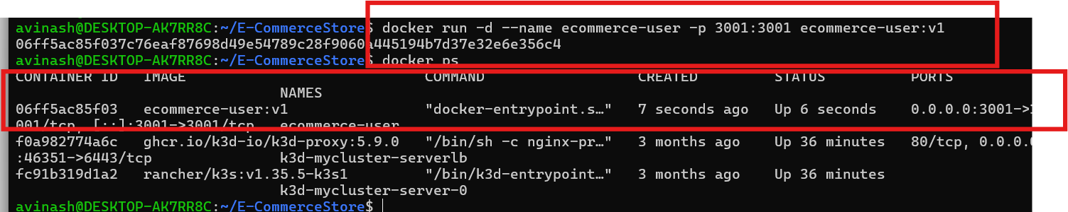
Using the same command and I am running all the other serives
All the five services are running
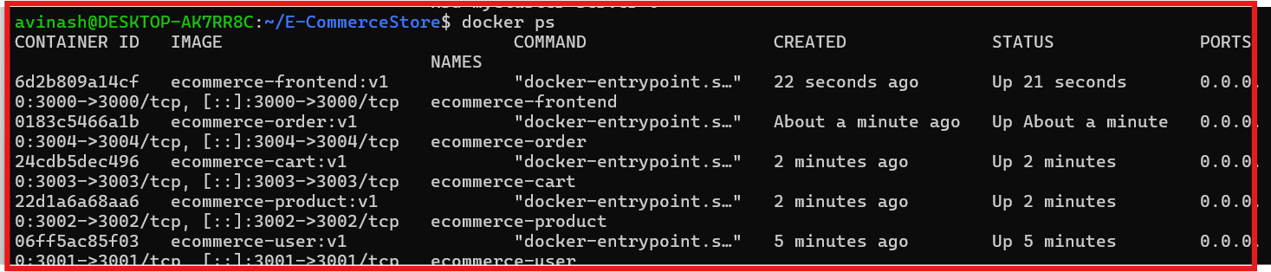

Check the front end
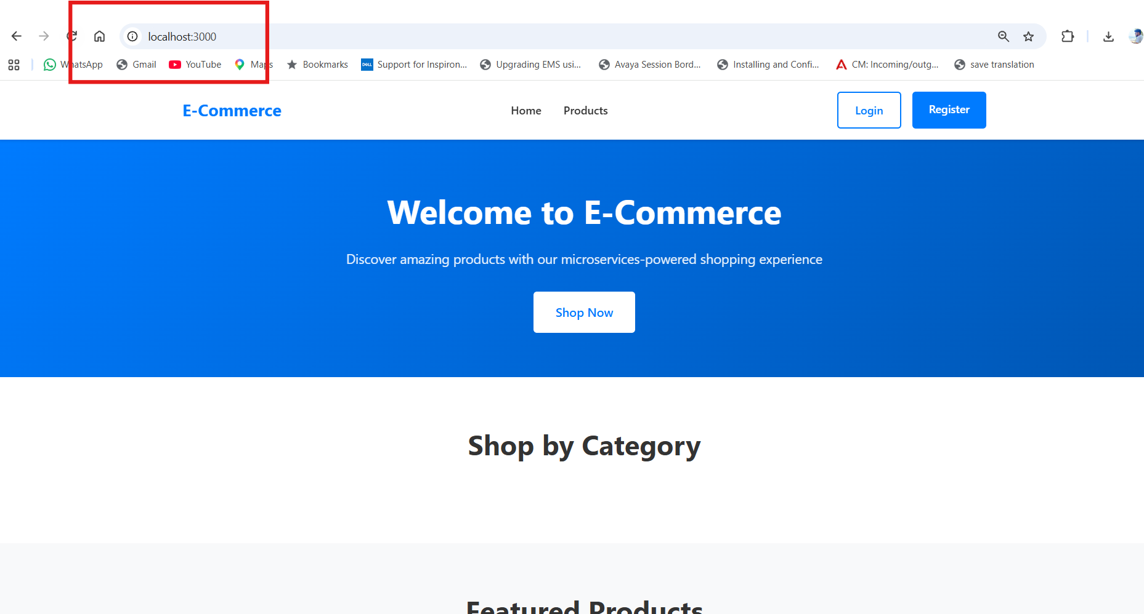
Now the AWS ECR park ,
Add the aws access usied id
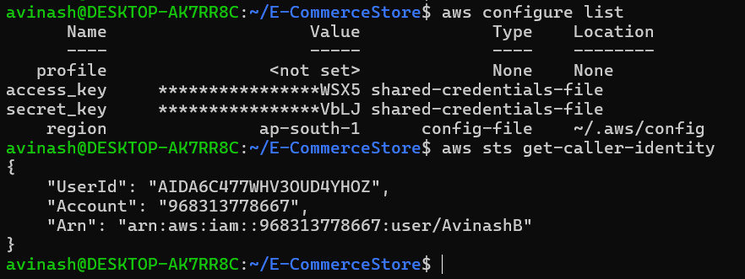
Now e we need to creat the ECR repo for the front end and back end
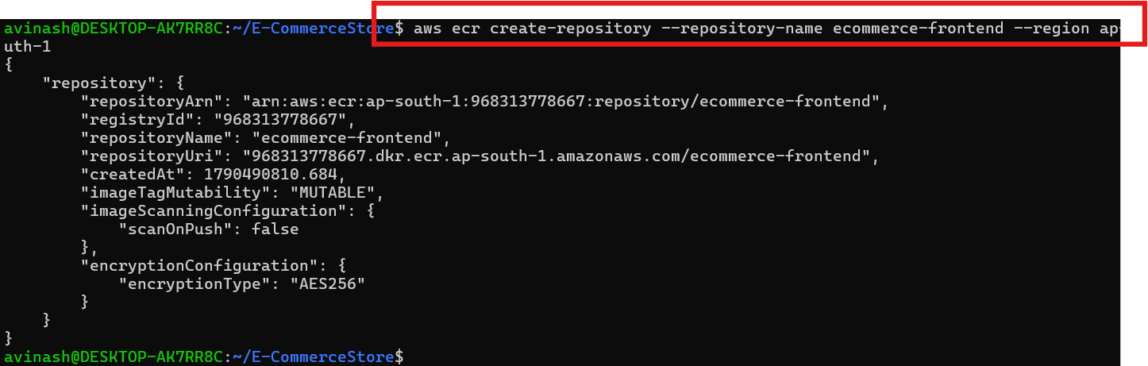
I can see all the 5 Repo in the ECR
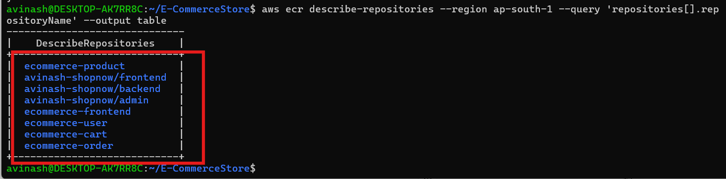

Login Docker to ECR

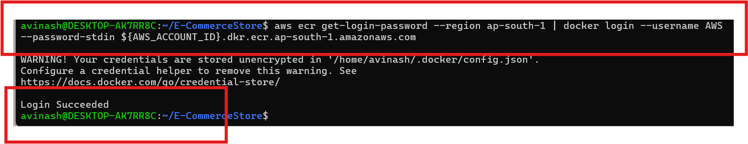
Now we need to tag the all the five services images
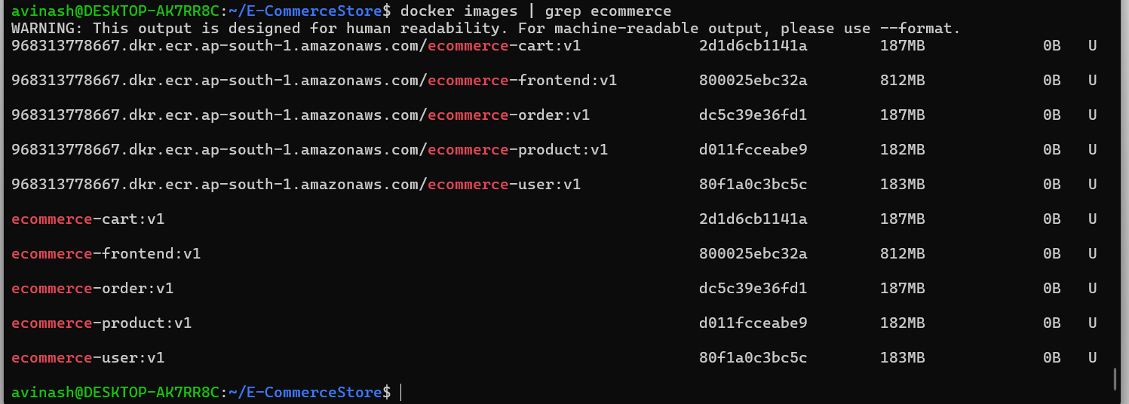

Now we need to push the images to ECR
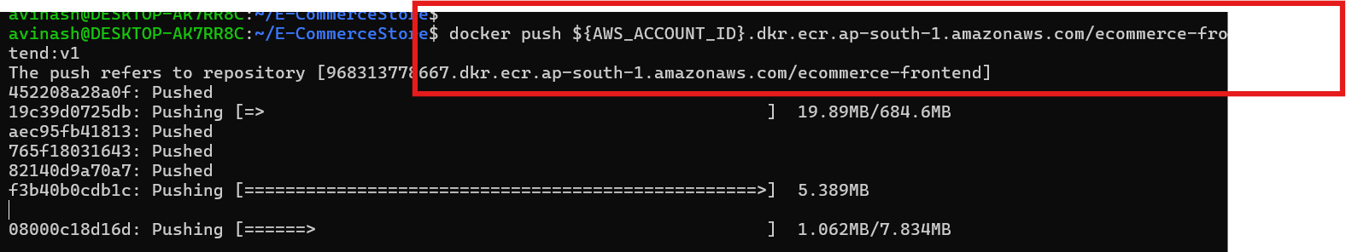

Created the folder for the terraform and created the configuration file
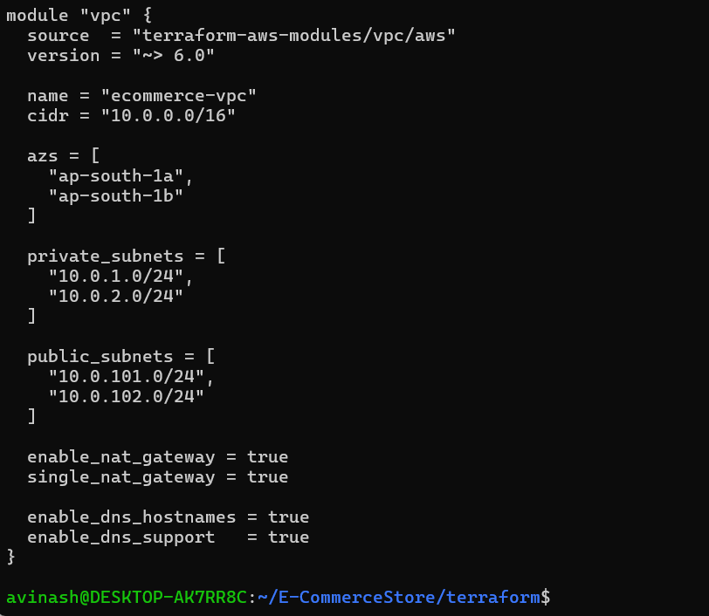
The terraform configution verfy success
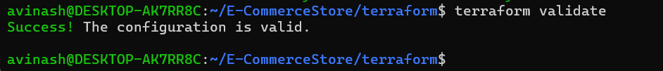
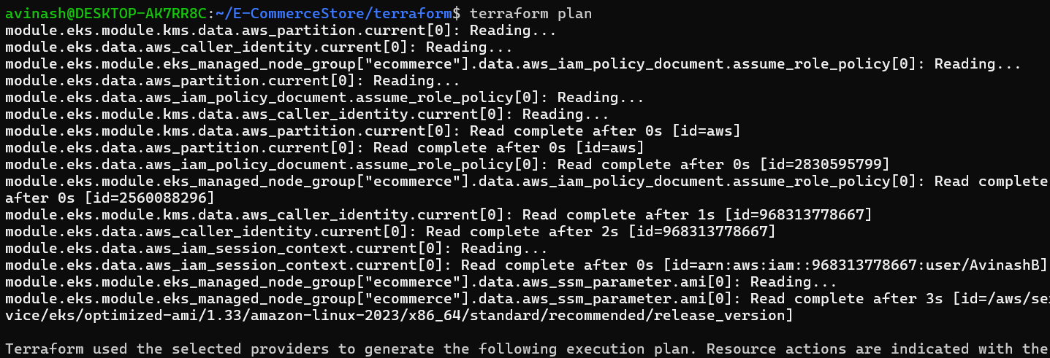
Connected to kubctl

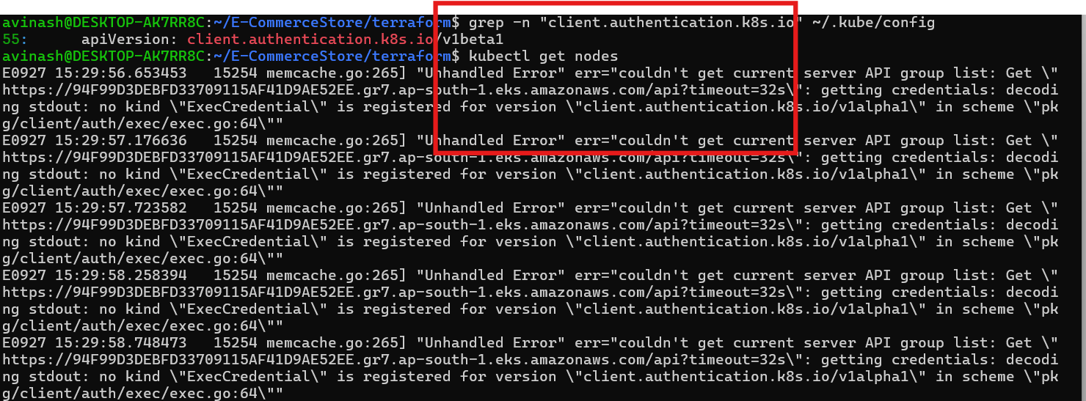
Added the IAM user to EKS
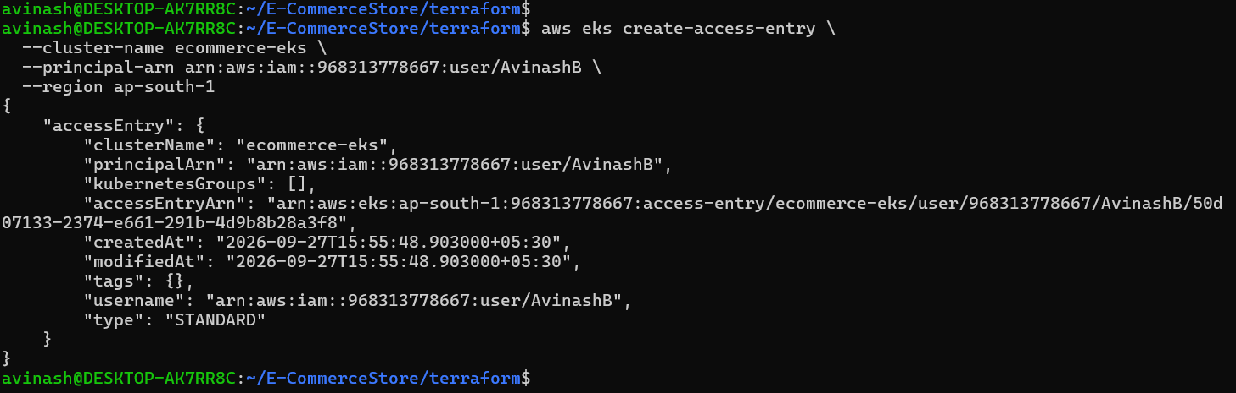

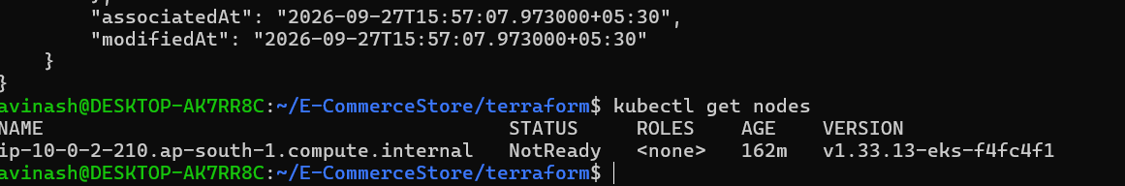
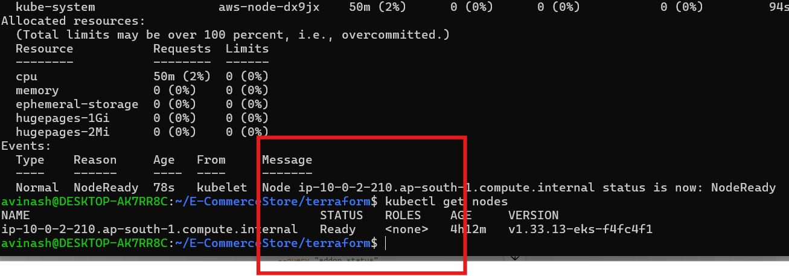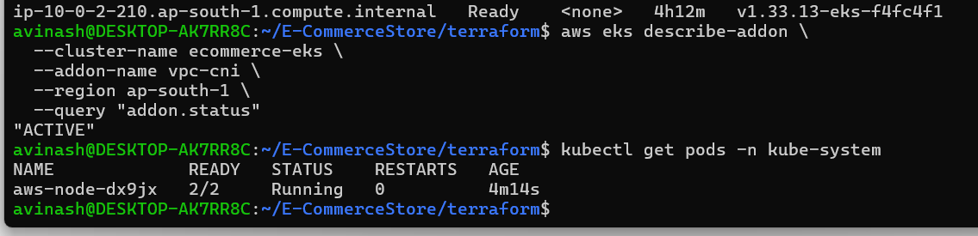

All the fi;es are created
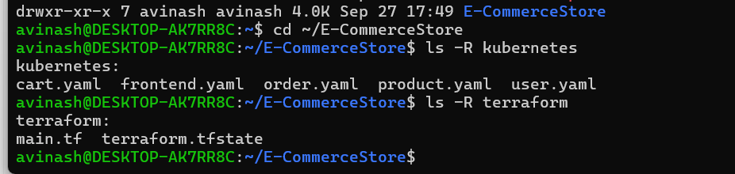

All the files are pused to the GGIT
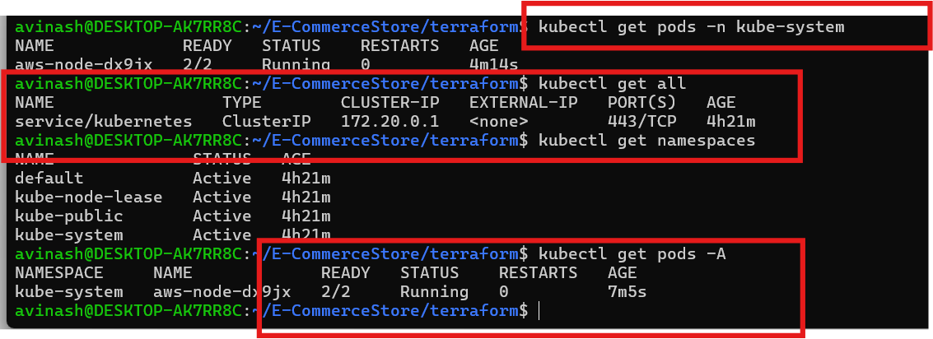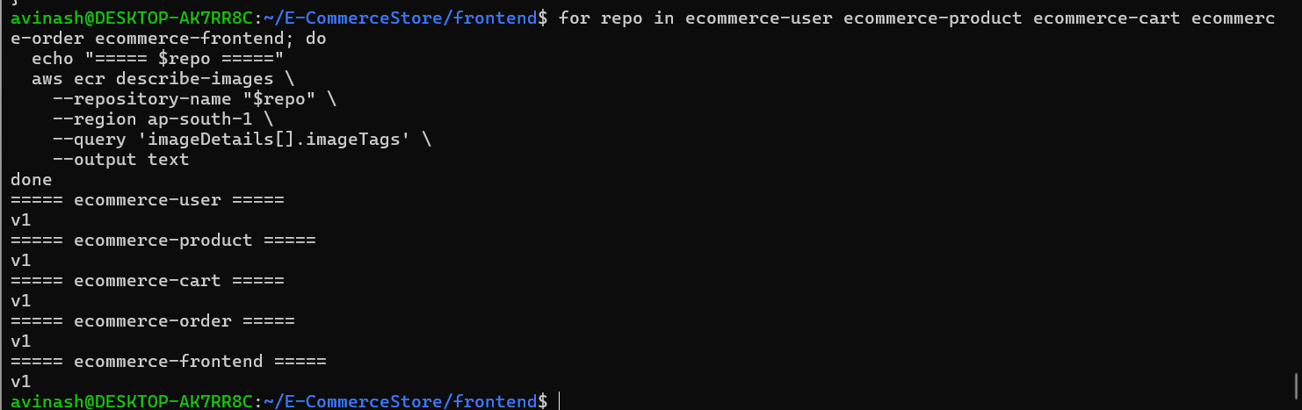
Kubernets:
